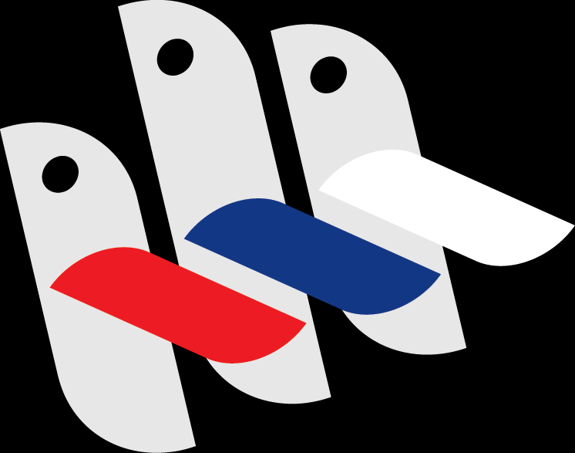

DJURDJEVDAN FESTIVAL OF CHILDREN SONGS
BANJA LUKA 2025

REPUBLIC OF SRPSKA - BOSNIA AND HERZEGOVINA
Banja Luka, May, 2025

PERFORMER APPLICATION

Name:: | Last name::
Date of birth: | Gender:
Country: | Residence:
Phone number: | E-mail:

By submitting this electronic form, as the parent (guardian) of the above-mentioned minor performer, I give consent for their participation in the Đurđevdan Festival 2025 and accept the Festival’s rules. I agree that photos, videos, and audio recordings of the child may be published in public media, used for promotional purposes, and that I transfer the performer’s rights to the organizer until the official contract or agreement is signed.

NOTE: DO NOT PRINT this document. Fill in the basic information about the performer on your computer or mobile phone, save the document in Word format (.doc, .xdoc), and send it as an application along with photos and a performance recording to the email: djurdjevdanskifestival@gmail.com.

Name and surname of the applicant:

